Supporting: MSFKB3003 Check and measure fit of cabinets

Section 2 Assignment: Using measuring devices
Name |  | Date

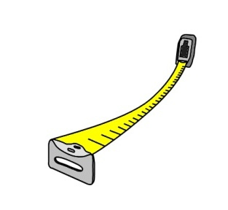
Question 1
You need to measure the width of a room with your tape measure. So you ask your offsider to hold the end of the tape against one wall while you stretch out the tape to the opposite wall.
However, you notice that there is a sag in the tape, because you’re both working at waist height and it is a long room.
(a) What effect will the sag in the tape have on the measurement?
(b) How can you overcome this problem?

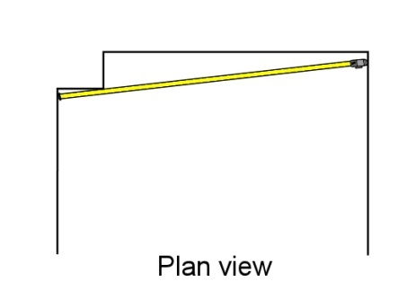
Question 2
At one end of the room there is a boxed-in section which houses a waste pipe. You need to measure the full length of the room, so your offsider holds the tape beside the boxed-in section while you stretch it across to the far corner.
But when you look back you can see that the tape is not running at right angles to the two walls.
- What effect will this angle have on the measurement?
- State two different ways you could overcome this problem by repositioning the tape. (Hint: one way will occur at your end, and the other way will occur at your off-sider’s end.)

Question 3
You have been given an old spirit level that looks a bit knocked around. You place it on the floor and find that the bubble is exactly in the middle of the vial, indicating that the floor is dead level.
But when you turn the level back-to-front and check it again, the bubble is now off centre.
- Is this level giving you accurate readings?
- What should you do with the level?

Question 4
What is the commonsense safety precaution to keep in mind when working with a laser level? (Hint: it concerns your eyes.)

